Sheet Harbour Marina Business Plan

The Sheet Harbour and Area Chamber of Commerce formally established the Sheet Harbour Marina Committee in 2013, to further the 2009 Sheet Harbour Waterfront Development Site Plan (www.halifaxpartnership.com/site/media) as developed by Ekistics Planning & Design. The development of a marina in the Sheet Harbour area was also part of the 1996 report developed by Environmental Design & Management Ltd., commissioned by AESTA.

EXECUTIVE SUMMARY

1.0 Background

Situated along the Eastern Shore of Nova Scotia, Sheet Harbour is a good place in which to live, work, raise a family and eventually retire. The community is nestled among a multitude of other smaller coves and inlets along the eastern shore of Nova Scotia. In addition to being a friendly community, Sheet Harbour offers its residents a low cost of living, very low crime rates and access to a wide variety of recreational amenities.

Sheet Harbour is a rural hub situated approximately 120 kilometers from the capital city of Halifax and a sailing distance of approximately 8 hours from docking in Halifax Harbour.

  - Industry Analysis

There are an estimate 16.7million pleasure boats in the US (excluding paddle craft such as kayaks and canoes). In Canada, there are an estimated 1.2 million power boats and sailboats and up to 1.3 million paddle craft. There are an estimated 90,000 pleasure craft in Atlantic Canada with 35,000 in Nova Scotia (excluding kayaks and canoes). Of the Nova Scotia total, an estimated 5,500 are sailboats and the remainder is power driven.

In the US, pleasure boating has increased 22 per cent between 2006 and 2010. Nova Scotia had the highest participation rate in boating in Canada in 2011 with 54 per cent, versus the national average of 38 per cent. PEI was second with 49 per cent.

Unlike the US, Canada experienced a boom in new boat sales in 2009 and 2010. Pre-owned boat sales were also huge in Canada in 2011, and together with stern drives and inboards, accounted for about 75% of sales in Canada and 80% of sales in Atlantic Canada. About 8% of these boats were longer than 24 feet, or what is often thought minimally large enough to travel offshore, giving us some parameters on the size of transient boater markets, including resident boaters.

There are no firm numbers on transient boaters visiting Nova Scotia each year, and this can vary considerably in any case. (There is a noticeable increase in 2016.)
- Data from the Bras d’Or Lakes, where many out-of-province boats end up, suggests that there may be as many as 200 from the US on a good year, with 100 probably being the average.
- There also appears to be about 40 to 50 boats from Europe each year, about half are from the UK.
- There appears to be 40 to 50 boats from Ontario and Quebec, about 10 from Newfoundland, 60 to 80 from PEI and 30 to 40 from New Brunswick visiting the Bras d’Or Lakes annually in recent years.
- In total, about 300 to 400 boats, depending on the year, visit Bras d’Or. In some years, flotillas show up and can increase numbers significantly. For example, The Cruising Club of America is known to visit the Bras d’Or Lakes every few years, often before heading to Newfoundland. No doubt the Marblehead to Halifax bi-annual race and various Tall Ships events swell numbers and also present targets of opportunity for the Sheet Harbour Marina. Sheet Harbour is halfway from Halifax to Cape Breton, being the perfect stop during the trip.
- Cape Breton has expressed interest in a Sheet Harbour Marina, envisioning a stop on the way to Race the Cape.

The 1997 Nova Scotia Marine Tourism Study, authorized by the Economic Planning Group of Canada, concluded that “while there is an opportunity to attract the cruising market (from) the eastern seaboard of the US, demand is likely to be limited” and “the primary opportunity to increase non-resident sailing activity is to attract demand from other maritime provinces, which represents a fairly small market." However, in 2001 MRA surveyed 300 US sailboaters along the US east coast from Maine to Maryland, which had a population of almost 50,000 sailboaters at that time. The survey results suggested that under relatively simple and inexpensive conditions, a minimum of 650 boats and/or boaters (about half of them wanted to charter) would come to Nova Scotia (allowing a 2-year lead time). The primary thrust of the initiative was just to provide these boaters with an invitation and foreknowledge. The major, but not prohibitive expense involved was in contacting them. About 50% of the US boasters surveyed had very little prior knowledge of Nova Scotia, However, foreknowledge of this area can easily handled these days on the Internet. The survey destination at this time was the Bras d’Or Lakes.

There is considerable demand for a marina in Sheet Harbour from resident and transients. (See Appendix “B”.) There are an estimated thirty boats at private moorings. Even if 5% of non-resident transient boaters that now pass by our Harbour on their way to Bras d’Or or just along the Eastern Shore come into the marina, it would suggest an influx of funds to our community. In simple terms, on average, if one boater has an expenditure of $125 per day for the 90-day boating season, generating $11250.00 would be a conservative estimate.

The Sheet Harbour Marina would bring new spending and a positive economic impact to Sheet Harbour from a number of sources:
- Transient boaters
- New launch ramp that bring new boaters
- New seasonal boaters from away who will leave their boats in Sheet Harbour
- New construction

The Marina in Sheet Harbour would fill service gaps, including a strong demand for a new boater destination. Sheet Harbour’s wonderful, deep-water harbour, beautiful rivers, community size and abundance of amenities could be considered a magnet for many boaters looking for a more diverse and exciting boating experience.

Revenue generation potential will correlate strongly to the number of seasonal boaters at the marina, and slip rates will correlate strongly to the services and amenities provided (not the least of which is the convenience provided to local boaters). There is evidence to support demand for no less than 10 seasonal boats at startup. Even without full service (a fuel dock and launch ramp are recommended, if affordable), the operation should support rates of $50/ft./season. Assuming that the average boat is 24 ft. long, 10 boats would generate revenues of $12,000 per year in slip revenues.

The May 4, 2016 Community Consultation at the General Meeting of the Sheet Harbour and Area Chamber of Commerce regarding the installation of moorings, and past Town Hall meetings show overwhelming community support for the marina.

1.2 Mission Statement

The Sheet Harbour Marina’s mission is to establish a recognized destination marina facility in its target market for slip rentals, boat maintenance services and amenities onsite and throughout the surrounding community.

1.3 Customer Profile

The Marina’s average client will be middle class living in the Marina’s target market. Some of the common traits will be:
- Annual income approx. $50,000 to $100,000
- Lives or works no more than 100km from the community of Sheet Harbour
- Will spend $150 to $1000 on slip rentals and boat maintenance
- Has a boat with a value between $10,000 and $170,000
In Nova Scotia, there are 62,468 people that have their pleasure craft registered that would require services of a marina on an ongoing basis.

The Sheet Harbour and Area Chamber of Commerce, Marina Committee, conducted a survey in 2014 on the Sheet Harbour Marina’s Facebook site indicated that 42% of respondents would be interested in renting a berth at a marina in Sheet Harbour and 92% would visit. The survey also indicated that 73% of respondents would be purchasing a boat in the future, indicating the growth potential for the area. Furthermore, 54% of respondents would be interested starting a marina related business in the area.

1.4 Management Team (Volunteer), Representative.

Catherine Farris

- A teacher, by profession, 1977-2010. Administrator from 2006 until 2010.

- Joined the Chamber in 2008. Became a Director in 2011 and responsible for the MacPhee House and the VIC until present. Member of the Multipurpose Centre Committee.

- Initiated the Marina Committee in 2013- Chair since its inception. During this time, the committee has looked at four sites. It has networked with many other marinas. It has become familiar with the workings of governments and received three grants. It has liaised with governmental organizations to further its project. Needless to say, it has learned a lot and are ready to build the Marina.

Dawn Howe-Power

- Career Practitioner on the Eastern Shore working for the YMCA Employment Centre. Because of her experience, she has insight as to employment opportunity needs in the area. She also has a large networking area for advertising.

- As a member, she has an extensive knowledge of the Mi’kmaw culture and its diversity.

- She has a boating operator’s license and passion for boating.

Marilyn Munroe

- Retail Management/Owner for 18 years with experience in inventory control, human resources, staffing and management. Financial budgeting and forecasting, advertising and promotion.

- Over 15 years in Multi Media Advertising including television and print.

- Fundraising to foundations and corporations through targeted giving. Certificate training as Certified Fund Raising Executive -CFRE

- Administration and accounting for family-owned construction business for over 25 years.

- Past President of the Chamber of Commerce and currently serving as Vice President

Ed Empringham

• Veterinarian with 47 years professional experience primarily in the agriculture sector in Canada and including a number of international consulting and technology transfer trips. Currently a self-employed consultant/project manager working with the Canadian Animal Health Coalition and the National Farmed Animal Health and Welfare Council.
• Active in professional associations, alumni and the College of Veterinarians of Ontario.
• Over forty years' experience with agricultural and professional non-profit organizations. Achieved the status of Certified Association Executive.
• Lead project manager on multiyear, multimillion dollar federal contracts in agriculture for the Canadian Animal Health Coalition. Responsible for achieving objectives, reporting to the federal funding program and other stakeholders and financial management.
• Member of the Board of Directors of the Sheet Harbour and Area Chamber of Commerce.
Anthony Farris

- Boating experience of 30 years- Mechanical and maintenance, dock building, installation and maintenance of moorings, boating experience in local waters. Familiarity with electronics, charts. Researching boating and attendance at boat shows in Canada and the United States.

- Family transportation business experience 30 years.

- Owned Marine service and maintenance business for over four years.

- Member of the Chamber since 2008. Founding member of the Marina Committee.

1.5 Expansion Plan

The organization will aggressively expand during the first five years of operation. The organization intends to implement marketing campaigns that will effectively target all marinas, yacht clubs and waterfront communities within the target market.

In summary, it is noted that the Sheet Harbour Marina, run by the non-profit Association, has significant potential as a national and international boating destination area, with a primary weakness that the area has been under promoted and is relatively unknown, due to the lack of boating infrastructure. The proposed marina, with its position between Halifax and Cape Breton, and it opportunities to provide service to the boating community, should experience significant demand from both seasonal and transient markets and enjoy the economic benefits of increased tourism and boater spending.

2.0 BUSINESS STRATEGY

2.1 Introduction

Throughout recent history, the need for marinas along the Eastern Shore, has been acknowledged. AESTA, under Mike Bloomfield, did a survey and found that marinas are lacking from those in Little Liscomb and West Petpeswick. The need for a marina in Sheet Harbour has long been identified and again was a part of the EKISTICS plan completed for the Sheet Harbour and Area Chamber of Commerce in 2008. Discover Nova Scotia has earmarked the proposed Sheet Harbour Marina as a strategic stop in its Nova Scotia visitors plan. Boaters from the Dartmouth Yacht Club have expressed an interest in the area as well as Enterprise Cape Breton. Bridgewater Marina has supported the current Marina Committee in its quest to build this facility once and for all. This year (2016) has seen an increase in the number of transient boats entering our harbour with no place to berth or moor. The Marina Committee applied (Dec. 2015) and has been approved to install 6 moorings in the Harbour.

Our position along the Eastern Shore is a welcome stop in travels along the way from Halifax to Cape Breton and many areas in between. With contemporary GPS and chart plotting, taking the inside passage along the Eastern Shore is safe and picturesque. With the acquisition of the 100 Wild Islands by the Nature Trust, the promotion of this area will be worldwide, appealing to many boaters. The tourism plan under the STEP (Strategic Tourism Expansion Program) program has identified the need for moorings and a marina in this area to support the increase of marine traffic. The time is ripe for a marina in Sheet Harbour!

Sheet Harbour is a community of approximately 1300 that has many amenities: grocery store, bank, credit union, hospital and emergency services, public library, gym, motels, restaurants and a pub, RCMP, service stations, hardware store, massage therapy, churches and halls, gift shops, retail stores, laundromat and the NSLC. But the attributes of the deep-water harbour with pristine shorelines that are sheltered from the weather, along with neighboring harbours and the many islands to discover, invite all boaters to experience the best of boating. Also, the water in the West and East Rivers and also the base of harbour is warm enough to enjoy a swim. Take a dinghy ride up the East River - very picturesque. Hike the trails and visit Taylor's Head Park and Sober Island. Friendly motorists will offer you a ride!

Our Marina will include seasonal and rental berths, electricity and water hook-ups, anchorages, a ramp, fuels, pump-out services, laundry facilities, storage facilities, parking, washrooms and showers, members and guest lounge, VHS access and daily-posted weather reports. The Marina will be owned and operated by a non-profit Association.

3.0 MARKETING STRATEGY

The Sheet Harbour and Area Chamber of Commerce, Waterfront Development – Marina Project, has shown concern for the lack of proper infrastructure for the recreational marine traffic that passes by our communities every year. It is our intention to address these shortfalls within a comprehensive, phased-in Marina Project.

Goals:
With the proposed Marina project situated within the Main Street area of Sheet Harbour, marine traffic will benefit from: uncertified helicopter pad, refuelling and boat repair, groceries and supplies, hospital, a drug store, dining, local entertainment, tourism information, local shops, banking, ATM’s, motels, B&B’s, shower and laundry facilities, garbage and disposal. All will be provided with friendly faces.
Purpose:
This marketing plan will be the blueprint of the Sheet Harbour Marina Association’s establishment of a tourism destination as well as a long-term opportunity for local existing business to flourish and the foundation for new entrepreneurial investments.
Picture:
To the visiting leisure marine traffic, the Sheet Harbour Marina will offer pristine waterways, dozens of islands, harbours, bays and inlets to discover along the way, making the Eastern Shore not only a perfect day trip for many boaters, but a welcome rest stop on longer journeys. It also has the potential of encouraging boaters to stay longer, plan vacations, visit year after year and consider residency.

Our target user for the Sheet Harbour Marina will be the local existing community that will be encouraged to grow through increased education, expanding amenities, boat tour opportunities for the members of the community without access to their own boat, attracting local residents (young and old) to learn the joy of boating and encouraging them to use the facility.

In regards to transient users, St. Peter’s Canal, Cape Breton Island, had 3000 boats pass through in 2011. CBSA reported that in 2011, 1100 pleasure craft entered Canadian waters from the United States. Boats travelling from the United States through to Halifax onto Cape Breton, and vice versa and in- between, pass by the mouth of Sheet Harbour. Halfway along this approximately 250-mile stretch of ocean offers a safe, convenient port. Once boaters have set their course for more than a day trip, Sheet Harbour Marina will have limited competition. There do exist private marinas along the way but none offer the amenities available in the Sheet Harbour area.

3.1 Marketing Objectives
- Develop an online presence by developing a website and social media sites and placing the marina’s name and contact information with online directories.
- Implement a local campaign with the Marine’s target market via the use of local media, advertising and work of mouth advertising.
- Establish relationship with boat/yacht dealers that will refer business to the Sheet Harbour Marina.
- Promote the Sheet Harbour Marina to all yacht clubs, marinas, point of entry for marine traffic throughout Atlantic Canada.

3.2 Marketing Strategies

- The Sheet Harbour Marina intends on using a number of marketing strategies to generate immediate rental of slips within the Sheet Harbour area. Foremost, the Marina will develop relationships with nearby boat and yacht dealers that will provide the Marina with an influx of referrals among people that have recently purchased boat or yachts.
- The Marina will also use an internet based strategy. This is very important as many people seeking local services, such as marinas, now use the internet to conduct their preliminary searches. The Marina will register the Sheet Harbour Marina with online portals so that potential customers can easily reach the business. The marina will also develop its own online website showcasing the marina, its facilities, its management, preliminary pricing information and relevant contact information along with directions to the facility.
- The Marina will maintain a sizable amount of print and traditional advertising methods with the local markets to promote the marina rental and boat maintenance services that this area is selling.

Tourism
The Sheet Harbour Marina installed 6 moorings in Sheet Harbour in 2017. Word got out (via website, vessel to vessel, Cruising Cape Breton, Waterfront Development, etc.) and ships and boats were very glad to have a place to berth. A 130 foot cabin cruiser is coming in to the Provincial wharf next season. A flotilla of 6 boats "booked" the moorings and stayed in 2018 summer. For the last two years, we have bee recording the boats that have been coming in (to the best of our knowledge) and the numbers are increasing!
WITAP is extremely interested in having the Marina, as it will be the closest to the 100 Wild Islands. Tourism has really increased! Last year, the ship that was carrying the participants going from Halifax, through the Northwest Passage, tendered to visit the 100 Wild islands.
A documentary is being produced for CBC to show the "view to the shore."
Discover Nova Scotia (Waterfront Development) is actively interested in a marina in Sheet Harbour. They scheduled two meetings in September, 2018, to express their interest in tourism for this area, and to see how the Province may help establish a marina.
I already mentioned that there is no fuelling facilities from Dartmouth to Liscomb for boats!
A local company is gearing up to provide tours next season!
Having a Marina will allow boats to come in, boats and tours to be available for rent.

We have the services that tourism requires- except a marina to link the land and the sea.

Besides the boating, the symbiosis of the aboriginals and others working together to have the Marina can also to provide our heritage through art. Millbrook will be supplying an employee for the Marina. As well, the local Millbrook community is going to have an art/craft store and exhibition of aboriginal wares. We are very proud that Millbrook and we will be able to show tourists how cultures can flourish together. The Mi’kmaq will be able to build tourism from their heritage!

The following excerpt from the Chronicle Herald exemplifies the federal commitment to the 100 Wild islands. The Sheet Harbour Marina is very close to the 100 Wild Islands, and many further east.
April 1, 2017 - Sheet Harbour, NS - Atlantic Canada Opportunities Agency Canada's world-class tourism industry creates economic growth for middle-class Canadians. Further development and commercialization of experiential tourism and product branding along Nova Scotia's Eastern Shore will enhance business opportunities and help create additional jobs. Sean Fraser, Member of Parliament for Central Nova, on behalf of the Honourable Navdeep Bains, Minister of Innovation, Science and Economic Development and Minister responsible for the Atlantic Canada Opportunities Agency (ACOA), today announced a Government of Canada investment of $261,000 for Destination Eastern and Northumberland Shores Nova Scotia Association (DEANS). The funding is provided through ACOA's Business Development Program. With this support, DEANS will conduct research on the history, places and culture of the 100 Wild Islands area, a unique gathering of islands that has remained virtually untouched for 10,000 years. It provides one large ecosystem and encompasses a mosaic of every coastal habitat found in Nova Scotia. The project will facilitate the development of sustainable experiential tourism products, and include workshops to create service offerings in communities between Musquodoboit Harbour and Sherbrooke, as well as the development of a branding framework for the Eastern Shore. Other funding partners include the Government of Nova Scotia with a contribution of $40,500 and the Halifax Regional Municipality with a contribution of $37,200. Additional support for the project comes from the Nova Scotia Nature Trust, DEANS, the Sheet Harbour Chamber of Commerce and the Municipality of the District of St. Mary's. The Nova Scotia Nature Trust, an association dedicated to the protection of Nova Scotia's natural habitats and native species, is the primary leader and advocate for conservation efforts in the 100 Wild Islands area. Follow ACOA on Twitter: @ACOACanada (twitter.com/acoacanada)

4.0 FUTURE PLANNED AMMENITIES

4 berths for large yachts
Majority of berths can accommodate up to 40-foot vessels. Accommodations (4) available for larger vessels up to 130 feet.
Boat ramp.
Electrical hook-up for large yacht

5.0 GROWTH PLAN

Year 1 - Acquire site
- Floating dock for approx. 14 vessels
- Building renovation
- Fuel, Water & Electricity
- Laundry & Showers
- Office Space

Year 2 - Pump out
- Building renovation
- Large vessel berths
- Land acquisition (Parking expansion)
- Chandlery

6.0 OPERATIONAL PLAN as of Feb. 28, 2019
Sheet Harbour Marina
 |  |  | 1 year | 2 | 3 | 4 | 5
Income
Seasonal Berths |  |  | 18,000.00 | 20,000.00 | 20,000.00 | 20,000.00 | 20,000.00
Transient Berths |  |  | 2,200.00 | 5,000.00 | 5,000.00 | 9,000.00 | 9,000.00
Moorings |  |  | 500.00 | 500.00 | 500.00 | 500.00 | 500.00
Showers/Laundry |  |  | 250.00 | 250.00 | 250.00 | 250.00 | 250.00
Pump out |  |  |  | 1,500.00 | 2,500.00 | 2,500.00 | 2,500.00
Fuel |  |  | 2,000.00 | 2,000.00 | 3,000.00 | 3,000.00 | 3,000.00
Membership |  |  | 1,500.00 | 1,500.00 | 1,800.00 | 1,800.00 | 1,800.00
Fund Raising |  |  | 15450.00 | 11,050.00 | 12,150.00 | 9,750.00 | 10,350.00
Total Income |  |  | 39,900.00 | 41,800.00 | 45,200.00 | 46,800.00 | 47,400.00
Operation Expenses
Insurance |  |  | 4,500.00 | 4,500.00 | 5,500.00 | 6,000.00 | 6,000.00
Telephone |  |  | 1,500.00 | 1,500.00 | 1,500.00 | 2,000.00 | 2,000.00
Wharf Expense |  |  | 3,000.00 | 3,000.00 | 3,000.00 | 3,000.00 | 3,000.00
Utilities |  |  | 1,900.00 | 1,900.00 | 2,000.00 | 2,000.00 | 2,000.00
Wages |  |  | 25,000.00 | 25,000.00 | 26,000.00 | 26,000.00 | 26,000.00
Advertising |  |  | 1,000.00 | 1,000.00 | 1,000.00 | 1,000.00 | 1,000.00
Sewage |  |  |  | 1,300.00 | 2,000.00 | 2,000.00 | 2,000.00
Lease |  |  | 3000.00 | 3600.00 | 4,200.00 | 4,800.00 | 5,400.00
Total |  |  | 39,900.00 | 41,800.00 | 45,200.00 | 46,800.00 | 47,400.00
Profit/Loss |  |  | 0.00 | 0.00 | 0.00 | 0.00 | 0.00
Capital
Docks |  |  | 163,163.15
Fuel Station |  |  | 22,000.00
Electrical Service |  |  | 10,000.00
Marine Survey |  |  | Not required
Water |  |  | 10,000.00
Laundromat & Shower |  |  | 8,000.00
Pump Station |  |  |  | 17,000.00
Building Renovation |  |  | 80,000.00 |  | 25,000.00
Security System |  |  | 3000.00
Safety Equipment |  |  | 1000.00
VHF & Antenna |  |  | 2500.00
Architect |  |  | 20,000.00
Total Capital |  |  | 319,663.15 | 17,000.00 | 5,000.00

7.0 HUMAN RESOURCE PLAN

Having a manager would be crucial in a sustainable business, even with the marina’s operational season being the first of May to the end of October. This could be partially funded by Career focus or Targeted Initiatives for Older Workers through ESDC, as well as through Millbrook First Nations.

8.0 SOCIAL RESPONSIBILITY STRATEGY

Having the facilities at the Marina would preclude the need to dump in our waters. As well, having a protected fuel site will ensure the quick cleanup of spillage.

As the Marina continues to develop, recreational programs (canoeing, kayaking, stand up waterboarding, sailing) for children, youth and adults can become a part of the mandate of the Marina.

Working with the WITAP program on the 100 Wild Islands to promote and help provide sustainable recreation will develop the Eastern Shore into a natural, recreational destination.

9.0 E-BUSINESS STRATGEY

The types of marketing used by marinas depend partly on the mix of annual and transient customers. Word of mouth is very important. Contact boat brokers, neighboring marinas and yacht clubs, boating and cruising publications (Atlantic Boating Guide), trade and tourism events, boat shows, community rallies, runs and tournaments. The Internet plays a major role, with having a website presence that is maximized for relevant search keywords, blogging sites (Active Captain), Google map locators, as well as trade magazines and reports.

Financial forecasts and other information

Economics of a Marina

Using available statistics from the US Marina Industry, having a base of about 11,451 marinas, excluding private clubs- 60% are salt water and 75% are 25 years or older – with a median age around 40 years. A recent survey of 4,300 commercial marinas showed combined annual revenue of $3 billion. The average marina has between three and ten employees and many have revenues of $400,000. Today’s marinas are generally freestanding and dockage is considered the main profit center of the business.

Business exit strategy

As the Marina continues to make a profit, funds will be used to make improvements and add amenities. In the future, when it becomes a moneymaking business in its own right, it could become a private or municipal business.

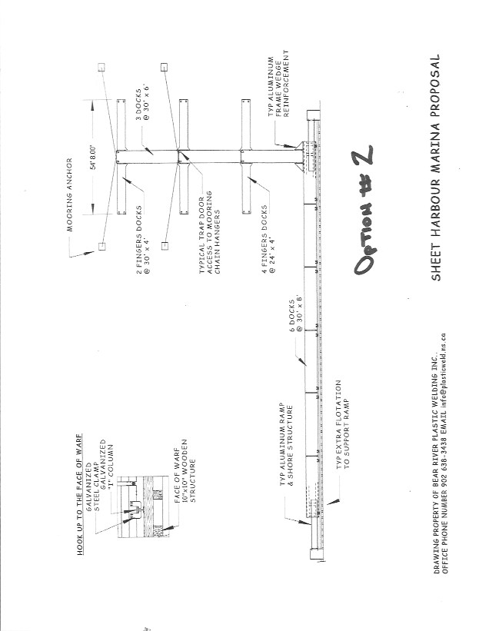

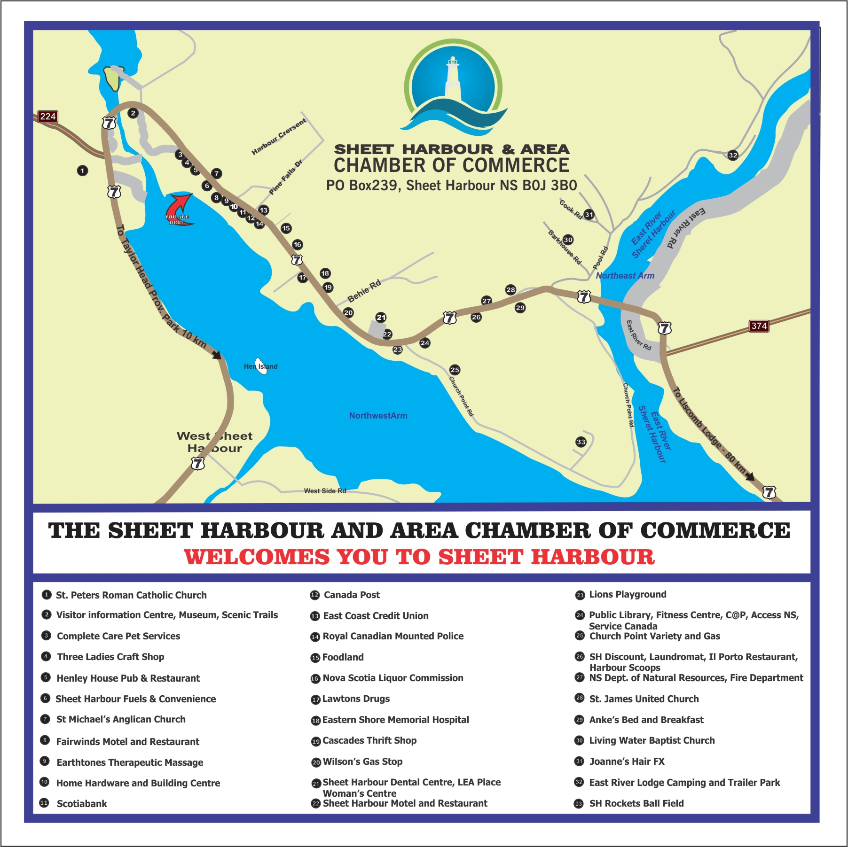

Appendix C Facebook Marina Survey

